**Class Task**

**Question 1 -> Write a java program to print all number from 1 to 100 i.e 1 2 3 4 5 6 7 ....... 98 99 100.**

**// SOURCE CODE**

class Number1{

public static void main(String args [ ] ) {

for ( int i = 1 ; i <= 100; i++){

System.out.print(i + " ");

}

}

}

**// OUTPUT**

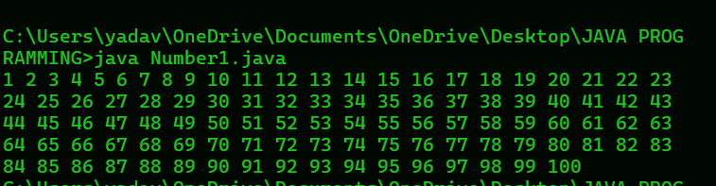

**Question 2 -> Write a java program to print alternate numbers starting from 1 to 99 i.e 1 3 5 7 9 11 13 ...... 95 97 99.**

**// SOURCE CODE**

class AlternateNumber{

public static void main(String args [ ] ) {

for ( int i = 1 ; i <= 99 ; i += 2) {

System.out.print(i + " ");

}

}

}

**// OUTPUT**

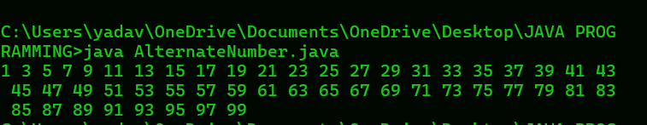

**Question 3 -> Write a java program to print alternate numbers starting from 0 to 100 i.e 0 2 4 6 8 10 12 .... 96 98 100.**

**// SOURCE CODE**

class AlternateNumber1{

public static void main(String args [ ] ) {

for ( int i = 0 ; i <= 100 ; i += 2) {

System.out.print(i + " ");

}

}

}

**// OUTPUT**

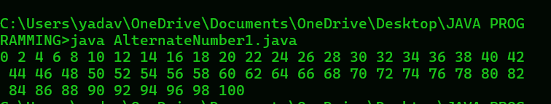

**Question 4 -> Write java program to print all numbers backwards from 100 to 0 i.e. 100 99 98 97 96 ..... 4 3 2 1 0.**

**// SOURCE CODE**

class BackwardNumber{

public static void main(String args [ ] ) {

for ( int i = 100 ; i >= 0; i --){

System.out.print(i + " ");

}

}

}

**// OUTPUT**

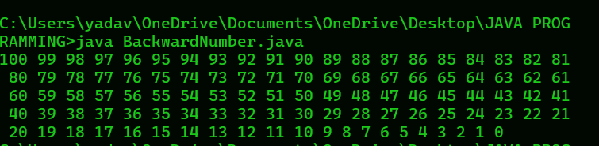

**Question 5 -> Write java program to print numbers backwards from 100 to 1 by skipping 2 numbers i.e 100 97 94 91 88 85 82 79... 16 13 10 7 4 1.**

**// SOURCE CODE**

class BackwardSkip{

public static void main(String args [ ] ) {

for ( int i = 100; i >= 1; i -= 3){

System.out.print(i + " ");

}

}

}

**// OUTPUT**

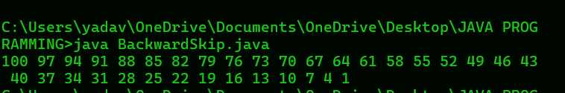

**// HOMEWORK TASK**

**Question 1 -> Write java program to print number from -5 to 5.**

**// SOURCE CODE**

class Number2{

public static void main(String args [ ] ) {

for( int i = -5; i<=5; i++){

System.out.println(i);

}

}

}

**// OUTPUT**

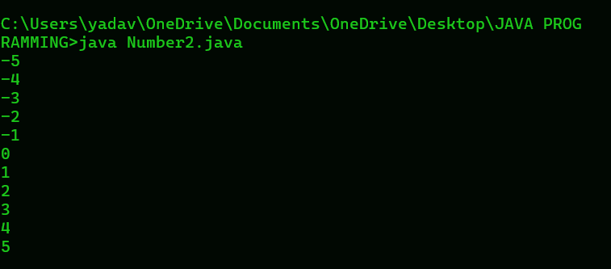

**Question 2 -> Write java program to print number from 100 to 91.**

**// SOURCE CODE**

class Number3{

public static void main(String args [ ] ){

for ( int i = 100; i >= 91; i--){

System.out.println(i);

}

}

}

**// OUTPUT**

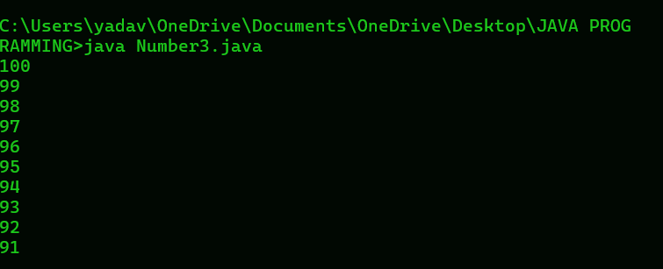

**Question 3 -> Write a java program to print alternate number from 80 to 70.**

// **SOURCE CODE**

class Number4{

public static void main(String args [ ] ){

for ( int i = 80; i >= 70; i -= 2){

System.out.println(i);

if ( i > 70) {

System.out.println("skip");

}

}

}

}

**// OUTPUT**

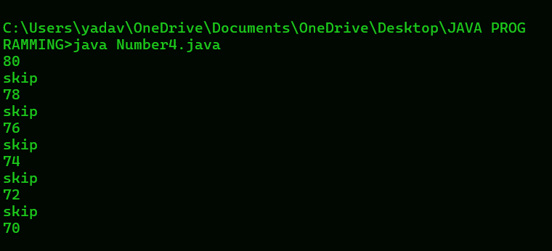

**Question 4 -> Write a java program to print square of Even number from 10 to 20.**

// **SOURCE CODE**

class SquareEven{

public static void main(String args [ ] ) {

for ( int i = 10; i<=20; i++){

if ( i % 2 == 0 ) {

System.out.println( i + " " + "Square is : " + i * i);

}

}

}

}

**// OUTPUT**

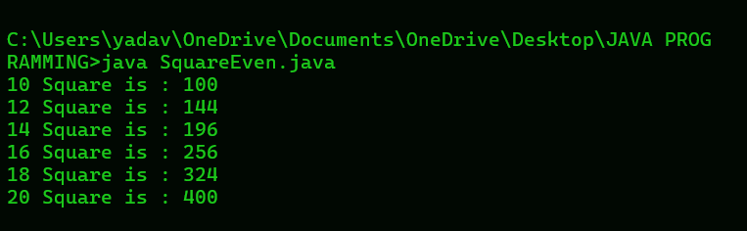

**Question 5 -> Write java program to print cube of odd number from 1 to 10**.

// **SOURCE CODE**

class CubeOdd{

public static void main(String args [ ] ){

for ( int i = 1; i <= 10 ; i++){

if ( i % 2 == 1) {

System.out.println( "Cube of " + i + " = " + i * i * i);

}

}

}

}

**// OUTPUT**

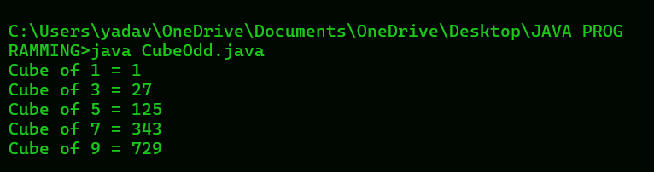

**Question 6 -> An Abundant number is a number for which the sum of its proper factors is greater than the number itself. Write a program to input a number and check and print whether it is an Abundant number or not**.

// **SOURCE CODE**

import java.util.Scanner;

class AbundantNumber{

public static void main(String args [ ] ) {

Scanner sc = new Scanner(System.in);

System.out.print("ENTER ANY NUMBER: ");

int n = sc.nextInt();

int sum = 0;

for ( int i = 1 ; i<=n; i++){

if( n % i == 0){

sum = sum + i;

}

}

if ( sum > n ) {

System.out.println("This is a Abundant number");

}

else{

System.out.println("This is not Abundant number");

}

}

}

**// OUTPUT**

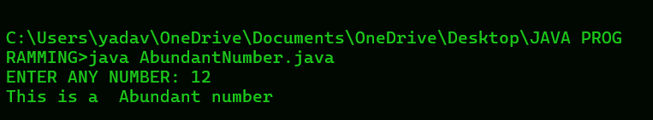

**Question 7 -> Write a java program to input a number. Check and display whether it is a Nivern number or not. ( A number is said to be Niven Which is divisible by the sum of its digit).**

**// SOURCE CODE**

import java.util.Scanner;

class NivenNumber{

public static void main(String args [ ] ) {

Scanner sc = new Scanner(System.in);

System.out.print("ENTER ANY NUMBER: ");

int n = sc.nextInt();

int sum = 0;

while ( n > 0 ) {

int r = n % 10;

sum = sum + r;

n = n/10;

}

if ( n % sum == 0 ) {

System.out.println("It is a Niven number");

}

else{

System.out.println("It is not a Niven number");

}

}

}

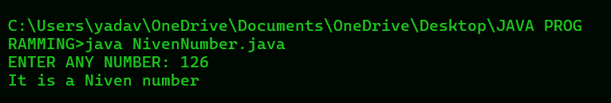

**Question 8 -> Write a java program to accept a number and check whether it is a 'Spy Number' or not . ( A number is spy if the sum of its digits equals the product of its digit.)**

// **SOURCE CODE**

import java.util.Scanner;

class SpyNumber{

public static void main(String args [ ] ) {

Scanner sc = new Scanner(System.in);

System.out.print("ENTER ANY NUMBER: ");

int n = sc.nextInt();

int sum = 0;

int product = 1;

while( n > 0 ){// 1124

int r = n % 10;// 4

sum = sum + r; // 0 + 4 = 4

product = product * r; // 1 * 4 = 4

n = n/10; // 112

}

if ( sum == product ) {

System.out.println("It is a spy number");

}

else{

System.out.println("It is not a spy number");

}

}

}

**// OUTPUT**

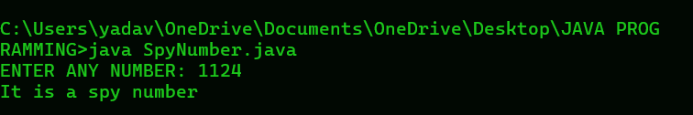

**Question 9 -> A special two - digit number is such that when the sum of its digit is added to the product of its digits, the result is equal to the original two-digit number**.

// **SOURCE CODE**

import java.util.Scanner;

class SpecialTwo{

public static void main(String args [ ] ) {

Scanner sc = new Scanner(System.in);

System.out.print("ENTER ANY TWO-DIGIT NUMBER: ");

int n = sc.nextInt();

int sum = 0;

int product = 1;

int m = n; // it store original value

while( n > 0 ) {//59

int r = n % 10;//9

sum = sum + r;// 0 + 9 = 9

product = product * r; // 1 * 9 = 9

n = n / 10;

}

int result = sum + product;

if ( result == m ) {

System.out.println("Special two-digit number");

}

else{

System.out.println("Not a special two-digit number");

}

}

}

**// OUTPUT**

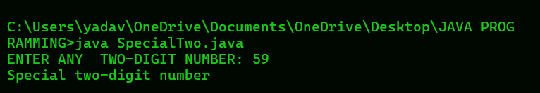

**Question 10 -> A number is said to be Duck if the digit zero is (0) present in it. Write a program to accept a number and check whether the number is Duck or not. The program display the message accordingly. (The number must not begin with zero).**

**// SOURCE CODE**

import java.util.Scanner;

class DuckNumber {

public static void main(String args [ ] ) {

Scanner sc = new Scanner(System.in);

System.out.print("ENTER ANY NUMBER: ");

String n = sc.next();

boolean duck = false;

if ( n.charAt(0) == '0'){

System.out.println("It is not a duck number because it start with 0");

return;

}

for ( int i = 1; i < n.length(); i++){

if ( n.charAt(i) == '0'){

duck = true;

break;

}

}

if ( duck ){

System.out.println("It is a duck number");

}

else{

System.out.println("It is not a duck number");

}

}

}

**// OUTPUT**

